H.T No
Regulations:
A19

Sreenidhi Institute of Science and Technology
(An Autonomous Institution)
Code No: 7Z102 Date: 12-July-2021 (FN)

MBA I-Year I-Semester External Examination, July - 2021 (Regular & Supplementary)
FINANCIAL ACCOUNTING AND ANALYSIS

Time: 3 Hours Max.Marks:70

Note: a) No additional answer sheets will be provided.
b) All sub-parts of a question must be answered at one place only, otherwise it will not be valued.
c) Missing data can be assumed suitably.

ANSWER ANY 5 OUT OF 8 QUESTIONS. EACH QUESTION CARRIES 14 MARKS.

Bloom's Cognitive Levels of Learning (BCLL)

Remember | L1 | Apply | L3 | Evaluate | L5
Understand | L2 | Analyze | L4 | Create | L6

 |  |  | BCLL | CO(s) | Marks
1. | a) | Discuss about any two accounting concepts and any two accounting conventions. | L2 | CO1 | [7M]
 | b) | Journalize the following transactions. Rs.  Jan.1.02 opened a bank account 10,000  Jan.2.02 Bought goods from Rama for cash 5,000  Jan.8.02 Rent paid to landlord through chq. 2,000  Jan.18.02 Purchased Machinery 15,000  Jan.20.02 Outstanding salary 8,000 | L4 | CO1 | [7M]
2. | a) | Prescribe Capital and Revenue items with examples. | L6 | CO2 | [7M]
 | b) | The following are the balances extracted from the books of Sri Balaji Enterprises as on 31st March 2000. From these balances and information given, prepare his Trading and Profit and Loss Account and Balance Sheet.  Trial Balance as on March 31, 2000  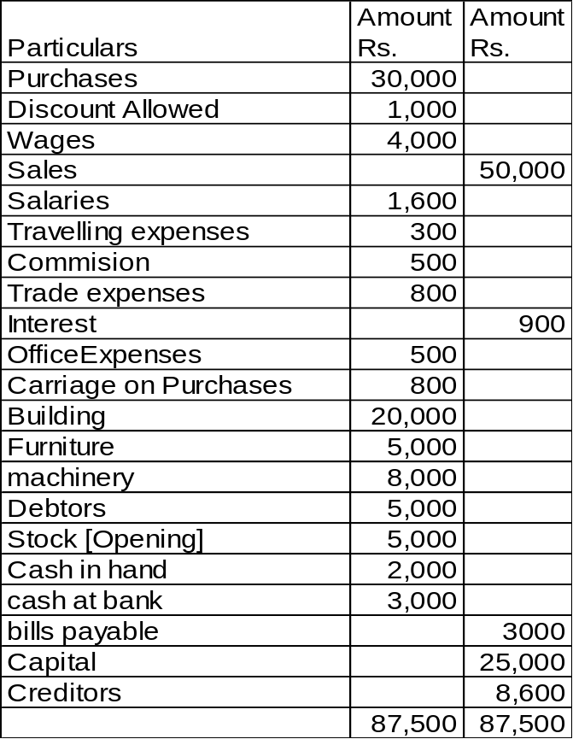  Adjustments:  - Closing stock valued at Rs.11000  - Write off Bad debts Rs. 500, and create provision for doubtful debts on debtors at 5% | L4 | CO2 | [7M]
3. | a) | Define Goodwill? And describe any two popular methods of Goodwill. | L1 | CO3 | [7M]
 | b) | Explain the costs for Inventory Valuation. | L2 | CO3 | [7M]
4. | a) | Prepare common size Balance sheet based on the details provided. | L3 | CO4 | [7M]
  Liabilities | Amount | Assets | Amount
  Sundry Creditors | 20,000 | Cash | 10,000
  Outstanding expenses | 3,000 | Debtors | 25,000
  Loans | 66,000 | prepaid expenses | 50,000
  Capital | 1,80,000 | Stock | 15,000
  Reserves | 28,000 | Other Current Assets | 10,000
   |  | Fixed Assets | 1,60,000
   |  | Bank | 20,000
   |  | Bills Receivable | 7,000
   | 2,97,000 |  | 2,97,000
 | b) | Define Comparative size balance sheet. And also explain advantages of comparative size balance sheet. | L1 | CO4 | [7M]
5. | a) | Differences between Funds flow statement and Cash flow statement. | L2 | CO5 | [7M]
 | b) | From the following profit and loss account, calculate Funds from operations:  Dr. Profit and Loss Account Cr.  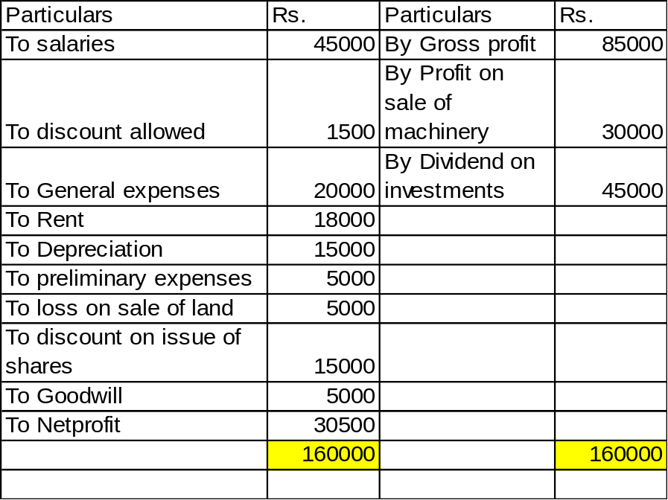 | L3 | CO5 | [7M]
6. | a) | “This ratio is computed to ascertain the soundness of the long term financial position of the concern”. Illustrate with imaginary figures. | L4 | CO6 | [7M]
 | b) | Following are the particulars pertaining to assets and liabilities of a company.  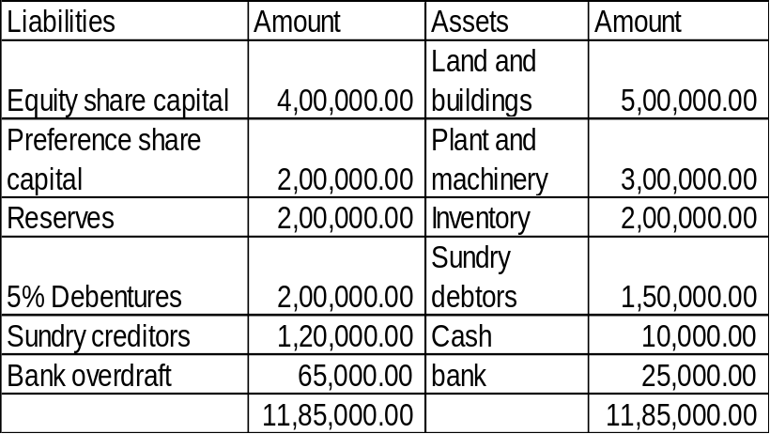  Calculate the following ratios and offer your comment on the ratios.  - Current ratio  - Fixed assets to Net worth ratio  - Quick ratio |  | CO6 | [7M]
7. | a) | Write adjustment entries:  - Depreciation on land and building  - Interest to be received  - Prepaid Insurance  - Interest on Drawings | L1 | CO1 | [5M]
 | b) | Describe why Trial Balance is important in accounting? | L2 | CO2 | [5M]
 | c) | Compute profit/loss on sale of machinery by following information:  1.4.04 machinery purchased Rs.1,00,000  1.4.04 installation expenses Rs.2,000  31.3.06 machinery sold for Rs.80,000  The books were closed on 31st march every year. Depreciation charged10% on machinery under straight line method. | L3 | CO3 | [4M]
8. | a) | Elucidate the purpose and significance of financial statement analysis. | L2 | CO4 | [5M]
 | b) | Draw the format of cash flow statement in direct method. | L1 | CO5 | [5M]
 | c) | Liquid ratio 2:1; current assets Rs.4,00,000; current liabilities Rs.1,50,000. Compute the value of stock. | L2 | CO6 | [4M]

-- 00 -- 00 –

